To check webdriverio version use npm ls webdriverio. It displays all webdriverio components versions

spec file syntax

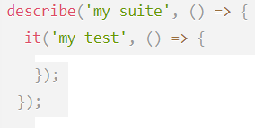

“describe” block contains Test suite name and callback function

“it” block contains a Test step and callback function

Browser Methods

1)url()-Open URL

Ex-

2) toHaveUrl()-



They are assertions

Ex-

To run wdio spec use 

Element operations-



Ex-







Ex-

$$(‘li’)

Handling Dropdowns-



3 methods are available

Handling Alerts-

4 methods are available

Taking Screenshots-

-



Ex-